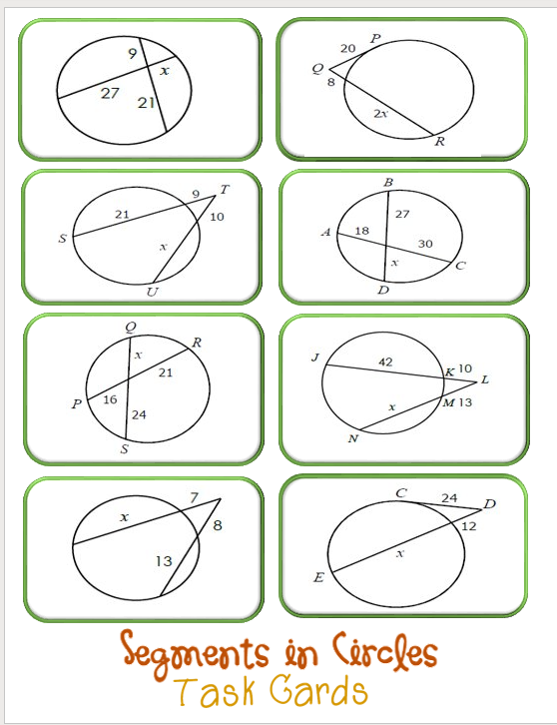
Feel free to print out this sheet.
Label this page in your composition notebook and complete this problems.

